UNDERGRADUATE PROJECT PROPOSAL

Project Title: | Comprehensive Personal Expenses Tracking System
Surname: | Wang
First Name: | Yingrui
Student Number: | 202018020316
Supervisor Name: | Maged Refat
Module Code: | CHC 6096
Module Name: | Project
Date Submitted: | October 27, 2023

Table of Contents
1 Introduction 2
1.1 Background 2
1.2 Aim 2
1.3 Objectives 2
1.4 Project Overview 2
1.4.1 Scope 2
1.4.2 Audience 2
2 Background Review 2
3 Methodology 2
3.1 Approach 2
3.2 Technology 2
3.3 Version management plan 2
4 Project Management 2
4.1 Activities 2
4.2 Schedule 2
4.3 Data management plan 2
4.4 Project Deliverables 2
5 References 2

Introduction

Background
As people's lives continue to enrich, effective management of personal finances is a common concern. Many people struggle with the complexity of tracking their expenses and income. This challenge stems from the diversity of income sources, expenditure diversity, and the necessity of maintaining financial stability (Gupta et al., 2020). In order to address these common financial difficulties and enable individuals to view their income and expenditure status promptly and control their financial situation, I hope to develop a web-based database management system (DBMS) to simplify personal expenditure and income tracking.

Aim
This project aims to create an efficient and user-friendly web-based DBMS to simplify personal expense and income tracking, enabling users to easily manage and monitor their financial transactions.

Objectives
The objectives are as follows:
- Complete a background check on personal expenditure and income tracking websites.
- Understand the technology required for the website and determine project requirements.
- Design an intuitive interface for users to access and use easily.
- Implement login and registration functions.
- Implement cost recording function.
- Implement expense classification function and customize expense categories.
- Implement a user fee suggestion function to help users spend within a reasonable range.
- Carry out test.
- Present the work to the audience.

Project Overview

Scope
This project aims to create a web-based DBMS to serve as a comprehensive platform for individual expense and income tracking. The software will facilitate expense recording and categorization and provide user consumption suggestions. It will simplify the process of tracking and managing finances, enabling people to achieve financial stability and timely control of personal expenses as a tool.

Audience
This product is suitable for those seeking convenient and efficient solutions to track and manage personal finances, including company, students, working professionals, entrepreneurs, and anyone who hope to understandtheir own expenses and have a clear plan for their consumption.

Background Review
The Comprehensive Personal Expenses Tracking System helps to manage our income and expenses daily or regularly, or to remind us at any time (Gomathy, 2022). The fee tracker can help users track their consumption habits and effectively manage their finances, which can help users determine the priority of spending and make wise decisions on resource allocation(Patil et al., 2023).
The comparison in Table 1 shows that various accounting websites have developed relatively complete functions in adding bills, viewing bills, modification of bill information, and bill reports, indicating that these functions are basic functions at the same level as login and registration. However, the import bill data and account information management functions do not cover all platforms, indicating that these functions are secondary. Most platforms do not implement the bill data analysis and synchronize bank card information function, which means that this function is a subsidiary function with low importance.

Table 1. Features Comparison of Different Websites.
Website  name  Website  Features | Zoho Expense | Sui shouji | Wa cai | Ai jizhang
Add bill | √ | √ | √ | √
View bill | √ | √ | √ | √
Modification of bill information | √ | √ | √ | √
Bill data analysis | √ | N/A | N/A | N/A
Import bill data | √ | N/A | N/A | √
Bill Report | √ | N/A | √ | √
Account information management | N/A | √ | N/A | √
Synchronize bank card information | √ | N/A | N/A | N/A

Methodology

Approach
With the Waterfall Model, the logical implementation is separated from the physical implementation with structured analysis and design methods. In this project, the software life cycle is divided into seven basic activities: requirements gathering, design, implementation, testing, deployment, evaluation, and operation maintenance. As shown in Figure 1.
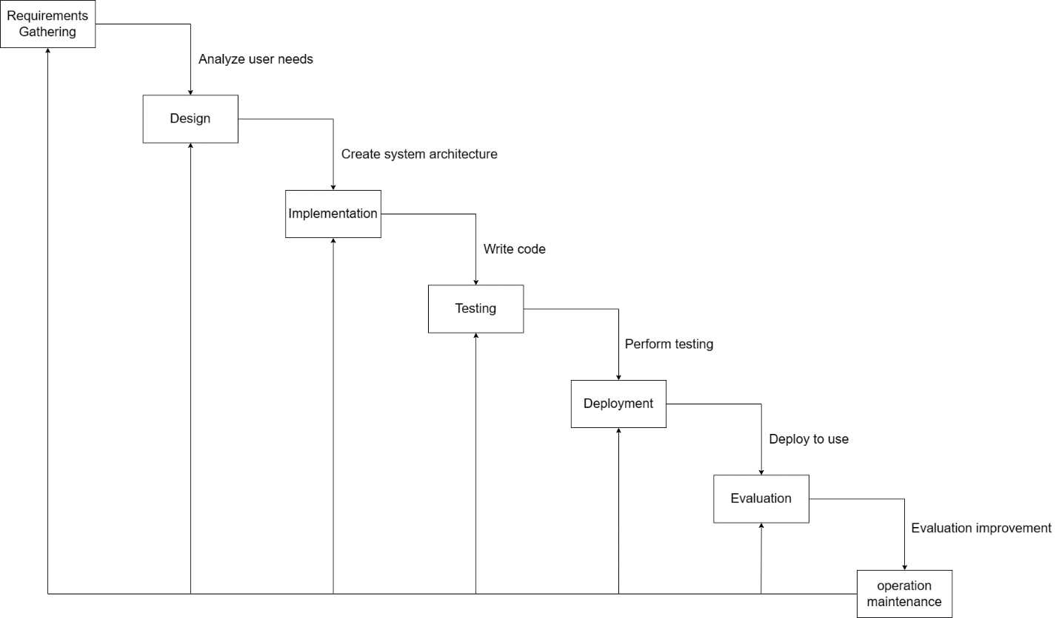
Figure 1. Software Development - Waterfall Model.
Our approach will involve the following key steps:
- Requirement Gathering: We will conduct interviews and surveys with potential users to collect their input and preferences.
- Design: Create wireframes and mockups to visualize the user interface and overall system architecture.
- Development: Implement features according to user stories and iterative sprints.
- Testing: Conduct regular testing, including unit testing, integration testing, and user acceptance testing.
- Deployment: Regularly deploy updates to a test environment for user feedback and then to a production environment.
- Evaluation: Collect user feedback and measure system performance.
- Operation maintenance: Make system changes and maintenance based on user feedback.

Requirement Gathering Method:
- User survey: Conduct a survey to gather valuable insights from potential users. These surveys aim to understand their specific needs, preferences, and difficulties in tracking personal expenses and income.
- User Interviews: Engage in one-on-one or group interviews with representative users to better understand their requirements.

Testing:
- Unit Testing: Individual components and modules will undergo unit testing to verify their correctness and functionality.
- Integration Testing: Test the interaction between different system components to ensure they work consistently.

Evaluation Process:
- User Feedback Collection: We will actively collect user feedback through the system's user interface. Users can report issues, provide suggestions, and express their overall experience.
- Performance Metrics: We will gather performance metrics such as system response times, error rates, and system uptime to assess the system's reliability and efficiency.

Technology
The technology used in this project is as follows:
- Hardware: Lenovo y7000p.
- Software: PyCharm, MySQL, Navicat, Microsoft Edge.
- Operating system: Windows 10.
- Visualization technology: ElementUI, Canvas, Excel.
- Background frame： Spring, SpringMVC, MyBatis.

Version Management Plan
Use Git repository to manage the version through the following URL:
https://github.com/Duinnn/202018020316_Project.git

Project Management

Activities

Table 2. The Objective and Task of Activities.
Objective | Task
Complete a background check on personal expenditure and income tracking websites. | - Research and review existing personal finance tracking websites.  - Document key features and shortcomings.
Understand the technology required for the website and determine project requirements. | - Identify the technology stack for front-end and back-end development.  - Gather and document project requirements based on user feedback and research.
Design an intuitive interface for users to access and use easily. | Create wireframes and mockups for the user interface.
Implement login and registration functions. | - Develop user registration functionality.  - Create a secure login system.
Implement cost recording function. | Develop the functionality for users to record their expenses and income.
Implement expense classification function and customize expense categories | Create a system for categorizing expenses and allow users to customize categories.
Implement a user fee suggestion function to help users spend within a reasonable range. | Develop a feature that provides spending suggestions to users based on their financial situation.
Carry out test. | Conduct various testing types, including unit testing, integration testing, and user acceptance testing.
Present the work to the audience. | Organize presentations to showcase the project to the target audience.

Schedule

Figure 2. Project Gantt Chart.

Data Management Plan
I will describe how I use Git to manage my project files according to Table 3:
- Upload the project code to the Code folder.
- Upload the final report material to the Final report folder.
- Upload the used literature to the Literature folder.
- Upload the other materials, such as videos, voice, and websites to the Other folder.
- Upload the presentation material to the Presentation folder.
- Upload the weekly report to the Weekly report folder.
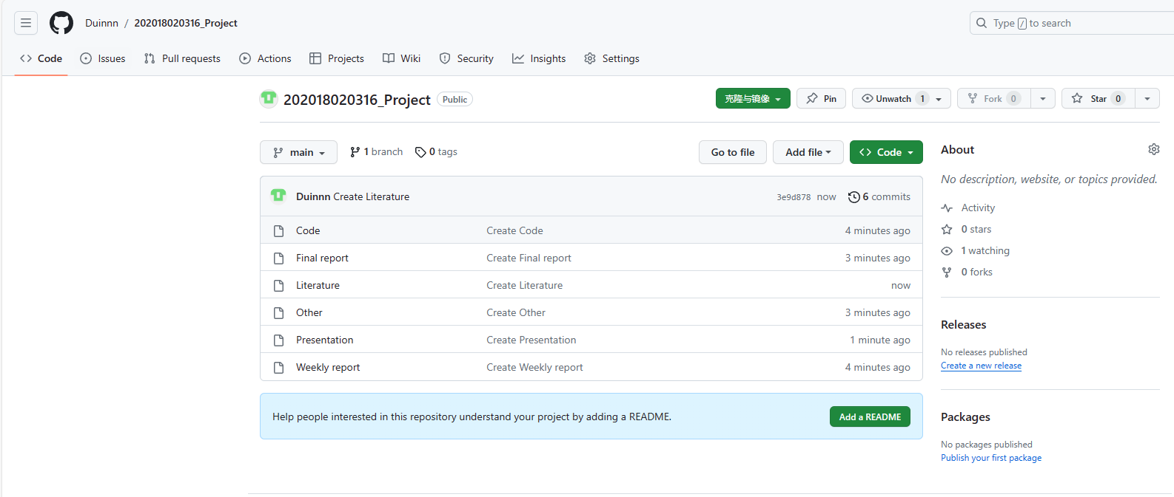
Figure 3. Data Management with Git.

Project Deliverables
The following files will be submitted for assessment:
- Project proposal.
- Progress Report.
- Weekly Reports.
- Final Project Report.
- Project Code.
- Presentation: slides, poster, and video.

References
Gomathy, C K. (2022) 'EXPENDITURE MANAGEMENT SYSTEM', ENGINEERING, COMPUTING & ARCHITECTURE, pp.182-184. Available at: https://www.researchgate.net/publication/360620084_EXPENDITURE_MANAGEMENT_SYSTEM, (Accessed: October 27 2023).
Gupta, Hrithik. et al. (2020) 'Expense Tracker : A Smart Approach to Track Everyday Expense', Available at: https://easychair.org/publications/preprint/73S7, (Accessed: October 27 2023).
Patil, Prof. Pallavi. et al. (2023) 'Personal Expenses Tracker', International Journal of Research Publication and Reviews,pp. 4357-4359. Available at: https://ijrpr.com/uploads/V4ISSUE3/IJRPR10840.pdf, (Accessed: October 27 2023).

